**EXPERIMENT 1**

ER DIAGRAM OF COLLEGE DATABASE

**Aim:** Draw an ER diagram of a college database.

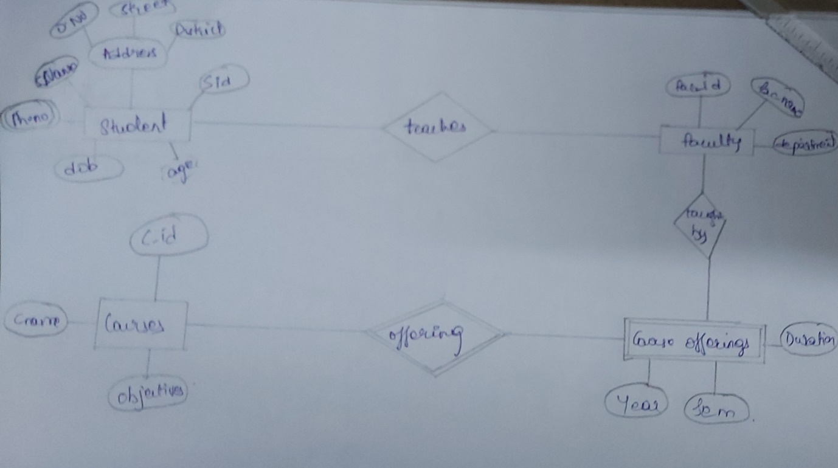

Offering

Bought by

Teaches

Course offerings

Courses

Faculty

Student